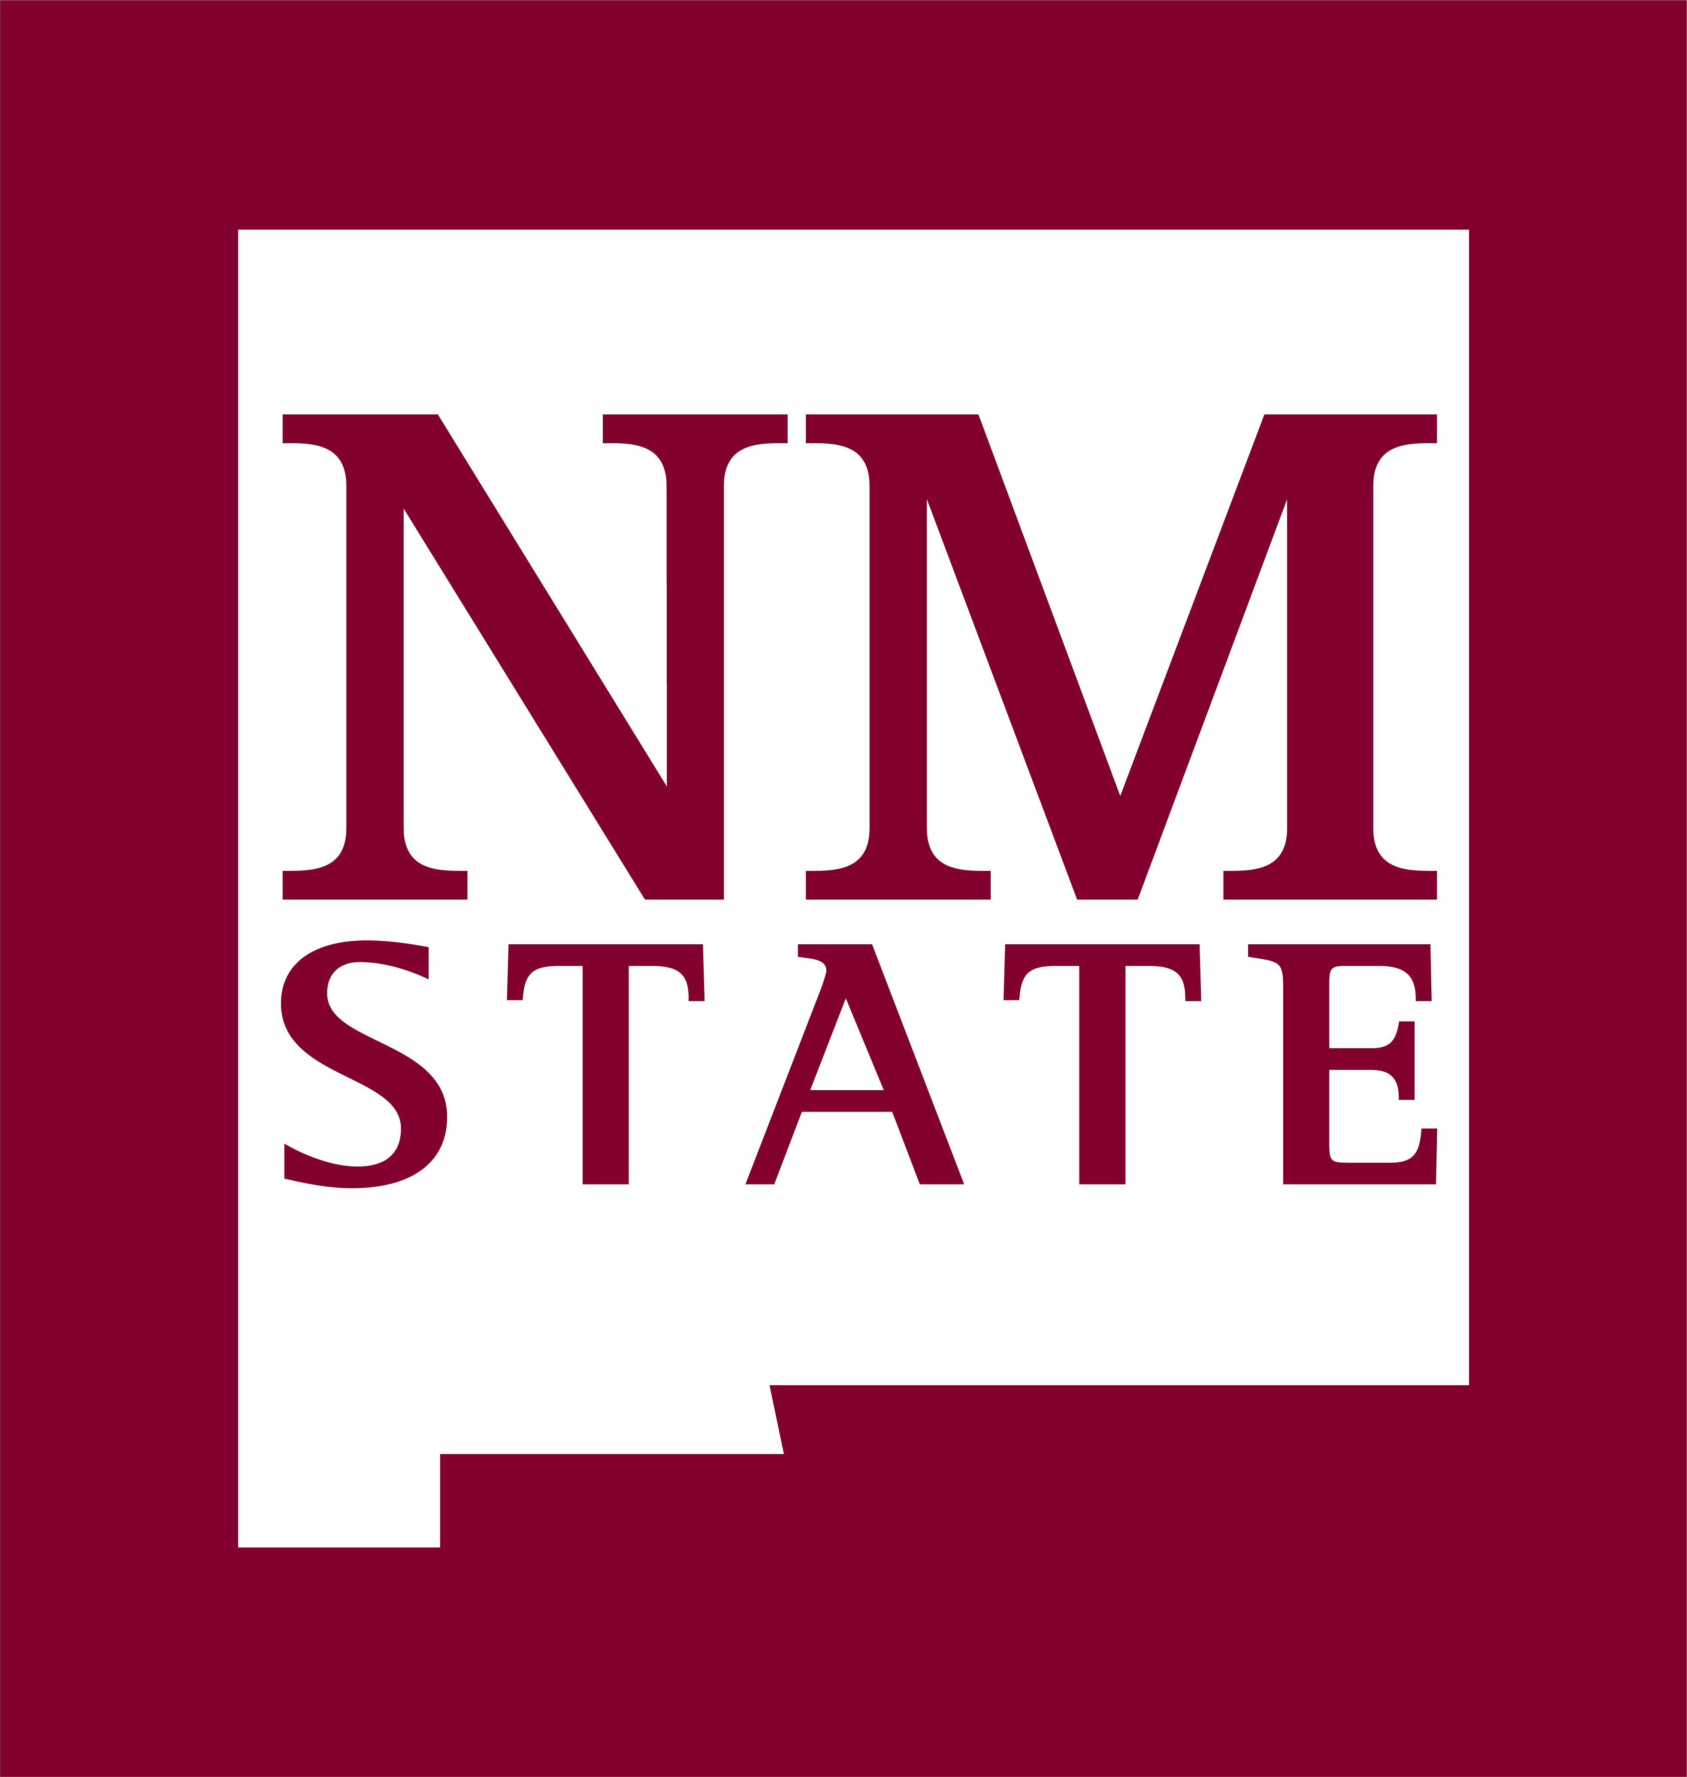

Benefit Services
MSC 3HRS
New Mexico State University
PO Box 30001
Las Cruces, NM 88003-8001
Phone: (575) 646-8000
Fax: (575) 646-2806
Family and Medical Leave Act
Certification of Adoption or Foster Care Placement

Note: Failure to provide a complete and sufficient certification may result in denial of your FMLA request and the related absences may not be FMLA-protected.

The due date for this Certification Form is: _________________

Your response is required to obtain or retain the benefit of FMLA protection.

Employee Name:_____________________________________________________________________________________
Last First MI

Aggie ID#: __________________ Work Phone:__________________ Home/Cell phone: __________________________

Child’s Date of Birth______________________
mo/dy/yr

- Describe facts relevant to the adoption/foster care placement/guardianship process for which you seek FMLA leave (such as required attendance of counseling session, court appearance, home visits, or consultations with involved parties):
_________________________________________________________________________________________________________________________________________________________________________________________________________________________________________________________________________________________________________________________________________________________________________________________________________________________________________________________________________________________________________________________________________________________________________________________________________________________________

- Indicate the need for absences:

Number of hour(s) per day __________ number of day(s) per week __________ / per month ___________
Beginning: _________________________ through last date: _________________________

*Additional documentation will be required for block leave. Please contact Benefit Services at (575) 646-8000 for more information.

Employee Signature: ______________________________________________________ Date ______________________

Certification forms can be delivered to Benefit Services Hadley Hall room 17,
faxed to 575-646-2806, or emailed to fmla@nmsu.edu.

