Retirement Checklist
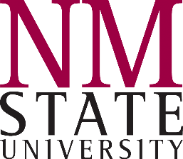
Educational Retirement Board
Alternative Retirement Plan

1-2 MONTHS BEFORE
- MEET WITH BENEFIT SERVICES
  - ARP retirement paperwork from retirement vendor
    - Upon retirement, ARP participants have three options:

a monthly annuity based on the retiree's estimated life span,
payments received over a fixed term of years, or
a lump-sum payout.
    - NMSU to confirm date of termination –letter of resignation will be required before NMSU can sign the documents

Please note that once paperwork has been completed, information regarding your pending retirement may be shared with your department.
OTHER CONSIDERATIONS
  - Social Security
    - Contact SSA within 4 - 6 months of eligibility to collect benefits
  - 403(b)/457(b) Plans
    - Contact vendor for appropriate forms
    - Allow 4-6 weeks to complete request process

1 MONTH BEFORE
- PAF (Personnel Action Form) Done by Department upon receipt of letter of resignation
  - Your resignation letter should be submitted to your supervisor by the first of the month prior to your retirement date.
    - 9 month faculty should provide notice no later than 3 months before the beginning of the next academic year or as soon as possible once retirement paperwork is completed.
  - The PAF and resignation letter must reach Hadley Hall Payroll Department by the first week of the month in which you last work to ensure vacation/sick leave balances are paid correctly, if applicable.
    - Accrued annual leave will be paid out in a lump sum up to a maximum of 240 hours at 100% of the base salary. The gross payment is taxed per federal and state guidelines.
    - For Employees who have been grandfathered as of July 1, 2016:
      - Accrued sick leave will be paid out in a lump sum for any accrued hours over 600 and less than 800 for a maximum payout of 200 hours at 50% of the base salary. The gross payment is taxed per federal and state guidelines.
        - EXEMPT/SALARIED employees should submit their final leave report for approval no later than the 15th of the month prior to their retirement.
  - If a PAF is not received in HRS by the 10th of the month prior to your retirement date, HRS will be contacting your department to inquire about the status of the PAF.

- MEMENTO
  - A memento commemorating your continuous years of service with New Mexico State University will be sent to the department from which you retired.
  - They should contact you to make arrangements for you to pick up your memento.

- NMERB
  - Working After Retirement
    - The requirements of the RTW Program and the RTW Exception also apply to persons retiring under the ARP. ARP retirees working under the RTW Program must pay the non-refundable contributions to the Fund. See, ERB Executive Director’s Policy Regarding Contributions by Retirees Working Pursuant to the Return to Work Program, effective July 1, 2011.
    - See ERB/NMSU Return To Work Information for details
  - Please visit www.nmerb.org periodically for NMERB updates

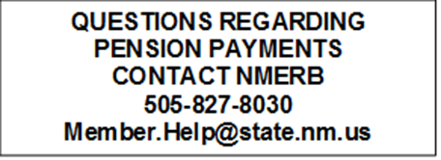
QUESTIONS REGARDING
NMSU RETIREE BENEFITS
CONTACT BENEFIT SERVICES
575-646-8000
benefits@nmsu.edu

